Given values
MTOM = 497870 kg
Aircraft length = 65.625 m
Body diameter = 6.3m
(Conceptual design):
- Centre of gravity height = 3.15m
- Main gear behind CG
- Tail clearance
- Vertical landing speed Vz
- Tyre deflection x_{t =}
- Landing factor
To find out
- Maximum landing mass
Conceptual assumption:
MLW = 0.9 x MTOM
= 0.9 x 497870 kg
= 448,083 kg
- Landing gear length estimate
For a large transport wide-body aircraft, the landing gear length is typically
L _{ldg} = 5.5 – 6.5 m

- Tail-strike angle

Assume tail near the end of aircraft:

- Tip-back angle

- Shock absorber stroke calculation
Landing energy equation:
6. Landing gear mass estimate ( Raymers)

Project Methodology
Landing gear sizing is iteratively updated within the MTOM convergence loop using current mass and geometry estimates.

make sure that landing gear positioning should be around 5% away from engines
MDO Development
1. Number of Wheels
A380 has MTOW 575t. So, it has 20 wheels.
Our aircraft has approximately 500.
Multi bogey addition- For High MTOW, we can use multi bogies (multiple wheel trucks per main strut, e.g., 4-6 wheels per bogie) to the tricycle base. For better load for flotation on runways, it reduces tire pressure.
We can use 20 wheels
Main gear wheel 18
Nose gear 2 wheels
Total = 20 wheels
2. Longitudinal Landing Gear position
Main Landing Gear should carry 85 % - 95 %
So, will take 90% for main landing gear.
Nose gear should 5% - 15% . Will take 10% for nose landing gear.
Tip Back angle: Aircraft must not rotate backwards.
β=tan−1(X_{cg} – X_{mg})/h_{cg}
1. Define the number of wheels required for the nose landing gear and main landing gear. Done in collaboration with Mass & Stability Engineer (MTOW estimate).
engineering justification.
* 18 main wheels + 2 nose wheels = 20 wheels
* Nose : Dual wheel for steering
* Main: Tricycle multi-bogie (two wing-mounted 4-wheels, two body-mounted 5-wheels)
For widebody track ~10m
For your aircraft (MTOW ≈ 1,097,522 lbs., 90% main load ≈ 987,770 lbs, 18 main wheels): Wheel load ≈ 54,876 lbs.
- $D=0.89×54,{876}^{0.361}≈0.89×51.39≈45.7$inches (≈1.16 m).
- $W=0.312×54,{876}^{0.361}≈0.312×51.39≈16.0$inches (≈0.41 m).
We are using the above calculations from Raymer's Type VII
For Type VII tires (high-pressure jet transport, ideal for widebody jets like yours due to high loads and paved runways):
- Diameter: A = 0.89, B = 0.361
- Width: C = 0.312, D = 0.361
The total weight of the landing gear is approximately ~20,000kg.
For main landing gear = 17600 kgs (90%)
For nose gear = 2400kgs (10%)
Maximum Landing mass
MLW = 0.9 x MTOM
= 0.9 x 497870 kg
= 448,083 kg
2. programmatically estimating the required longitudinal and lateral placement of the landing gear, respecting ground stability requirements as provided in the specialist material. Done in collaboration with the Mass & Stability Engineer (COM range).
For longitudinal placements, three constraints must be satisfied
1. Load Distribution
main gear – 90%
nose gear – 10%
2. Tip back angle
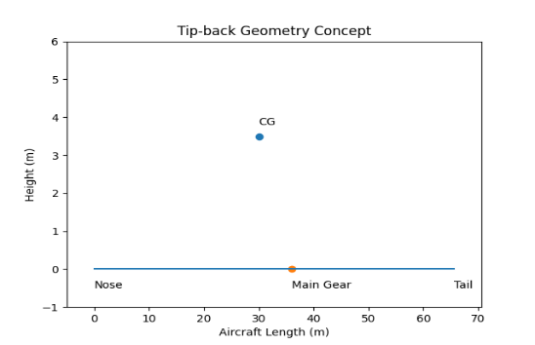

Landing gear length = Hw+0.3
= 3.62 +0.3
= 3.92 m
Tail Strike Angle
Tail strike angles protect the fuselage during rotation.
Formula:
$$θ_{tail}={tan⁡}^{-1}\left(\frac{h_{tail}}{l_{tail}}\right)$$
Tail height
Body radius:
$$R_{f}=\frac{6.3}{2}=3.15m$$
Add gear height:
$$h_{tail}=3.15+3.9$$
$$h_{tail}=7.05m$$Tail factor = $l_{tail}=0.0925×65.62$
$l_{tail}=6.07m$
θ=tan−1(7.05/6.07)
$θ={49.2}^{∘}$
Operational rotation angle:
$$θ_{operational}≈{12}^{∘}-{15}^{∘}$$Raymer recommended:
θ tipback ​=tan−1 (​hCG​​/ xCG−MLG)
$$θ_{tipback}={15}^{∘}$$CG height:
$$h_{CG}=3.15m \\ x_{CG-MLG}=\frac{h_{CG}}{\tan{{15}^{∘}}} \\ x_{CG-MLG}=\frac{3.15}{0.268} \\ x_{CG-MLG}=11.75m$$So, the main gear should be:
$$11.8m behind CG$$

